Safety: All safety glasses and appropriate safety apparel is to be worn at all times. If required, full acid suit with all compatible safety equipment should be used.

Purpose or Objective: The purpose of this procedure is to define the maintenance inspection of the acid hose and couplings

Procedure: The proper process for Acid Inspection (including hoses) by Maintenance is as follows:

- Monthly Acid inspection sheet will be used to determine repairs needed on the Acid delivery/storage system
- All acid hoses used for delivery will be pressure tested monthly at 60 pounds for low pressure for leakage.
- New hoses will be purchased pre-tested by manufacturer with tag, pressure limit tested, couplings already installed, etc. per industry standard specifications (ANSI and NORFALCO recommendations).

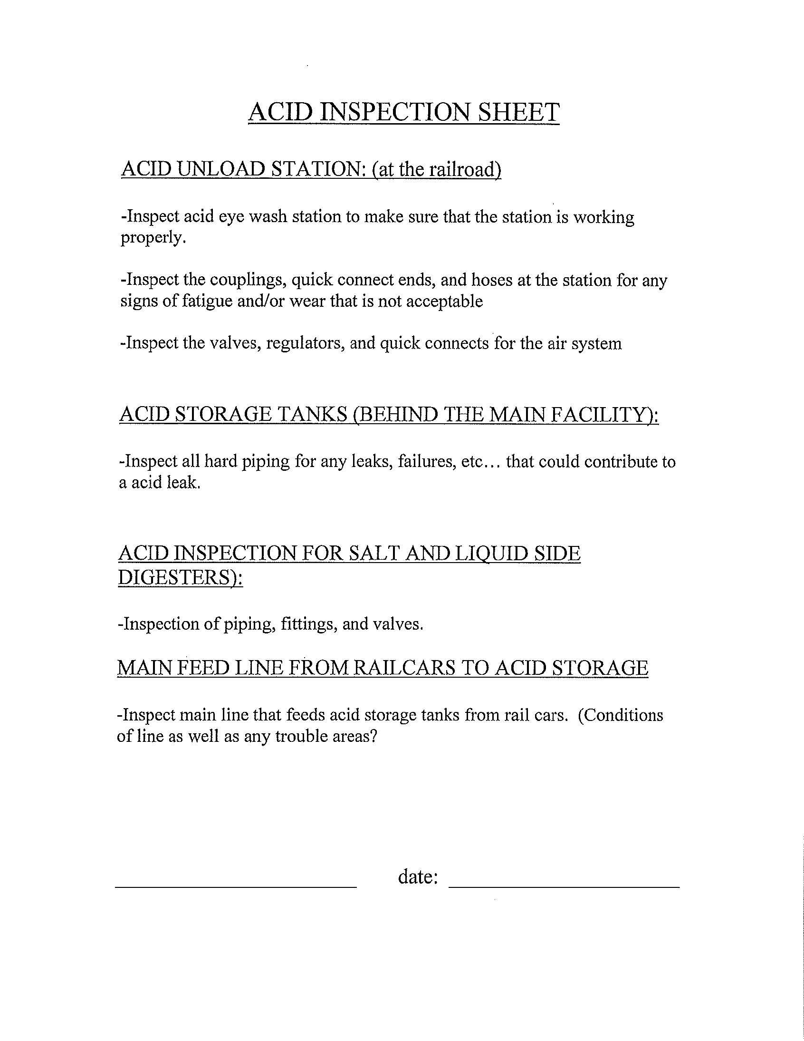

TRAINING DOCUMENTATION

 | EMPLOYEE | TITLE | SIGNATURE | DATE
1
2
3
4
5
6
7
8
9
10
11
12
13
14
15
16
17
18

REVISION HISTORY
Revision Date | Revision Number | Revision Description
10/01/2008 | 00 | New Document

